API Query Explorer

**Reference:**

<https://ga-dev-tools.appspot.com/query-explorer/>

<https://developers.google.com/analytics/devguides/reporting/core/v4/basics>

<https://www.klipfolio.com/blog/google-analytics-query-explorer>

<https://www.optimizesmart.com/how-to-use-google-analytics-api-without-any-coding/>

<https://docs.google.com/spreadsheets/d/16phR5_ntml9Hp7GleGRM7kDLf7zRyYPdBqvx30EGXiQ/edit#gid=1351568442>

**Task:**

Refine Filters at View level to create Manatt traffic, client traffic, developer traffic, remove Public Anonymous User hits and format Authentication queries to pages.

Define 5 Goals to track:

User Password change – event hit

Explorer – visit 5 different landing pages

Scholar – Visit 3 content pages for 10+ minutes done

Mobile – Access from a mobile/tablet device done

Follower – Visit Manatt SME page 2+ times

Add Custom Dimensions to track UID<https://www.simoahava.com/analytics/improve-data-collection-with-four-custom-dimensions/> at hit and session levels

<<<<<<<<<**Audience Overview**>>>>>>>>>

**Matrices Queries:**

**Ga:** Matrics: ga: users, ga: newUsers, ga:bounceRate, ga:sessions ga:pageviews, ga:pageviewsPerSession , ga:avgSessionDuration

<https://ga-dev-tools.appspot.com/query-explorer/?ids=ga%3A166047872&start-date=2018-09-21&end-date=2018-10-10&metrics=ga%3Ausers%2Cga%3AnewUsers%2Cga%3Asessions%2Cga%3AbounceRate%2Cga%3Apageviews%2Cga%3ApageviewsPerSession%2Cga%3AsessionsPerUser>

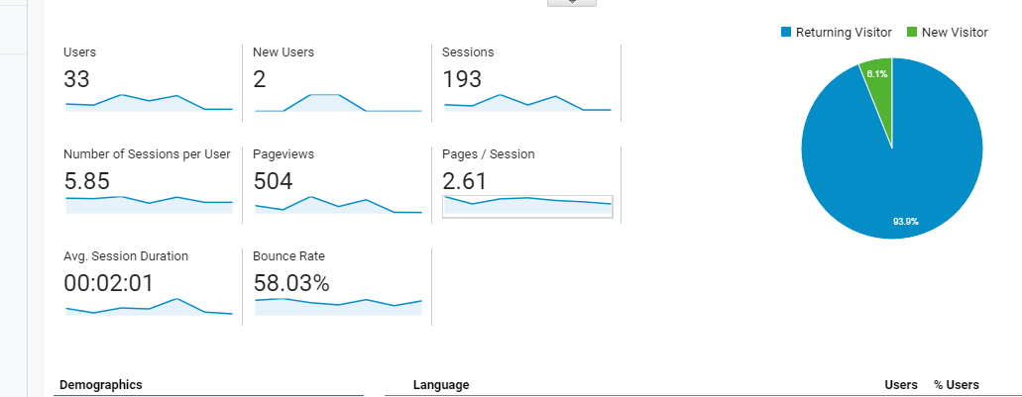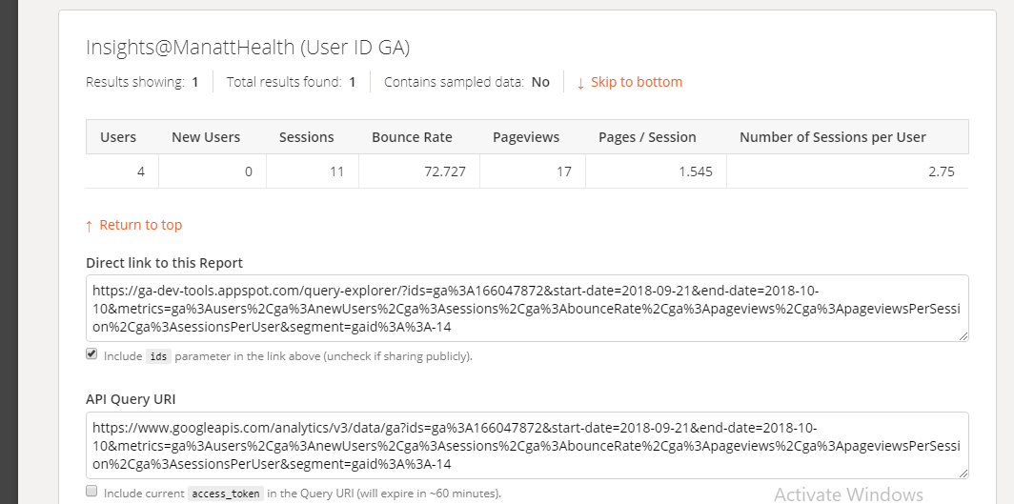

**Mobile/Desktop Overview:**

**Dimension**: ga:deviceCategory

Filter: ga:deviceCategory==mobile or Desktop

Matrics: ga: users, ga: newUsers, ga:bounceRate,ga:sessions ga:pageviews, ga:pageviewsPerSession , ga:avgSessionDuration

<https://ga-dev-tools.appspot.com/query-explorer/?start-date=2018-10-01&end-date=2018-10-15&metrics=ga%3Ausers%2Cga%3AnewUsers%2Cga%3Asessions%2Cga%3AbounceRate%2Cga%3AavgSessionDuration%2Cga%3AavgSearchResultViews&dimensions=ga%3AdeviceCategory&filters=ga%3AdeviceCategory%3D%3Dmobile>

<https://www.googleapis.com/analytics/v3/data/ga?ids=ga%3A166047872&start-date=2018-10-01&end-date=2018-10-15&metrics=ga%3Ausers%2Cga%3AnewUsers%2Cga%3Asessions%2Cga%3AbounceRate%2Cga%3AavgSessionDuration%2Cga%3AavgSearchResultViews&dimensions=ga%3AdeviceCategory&filters=ga%3AdeviceCategory%3D%3Dmobile>

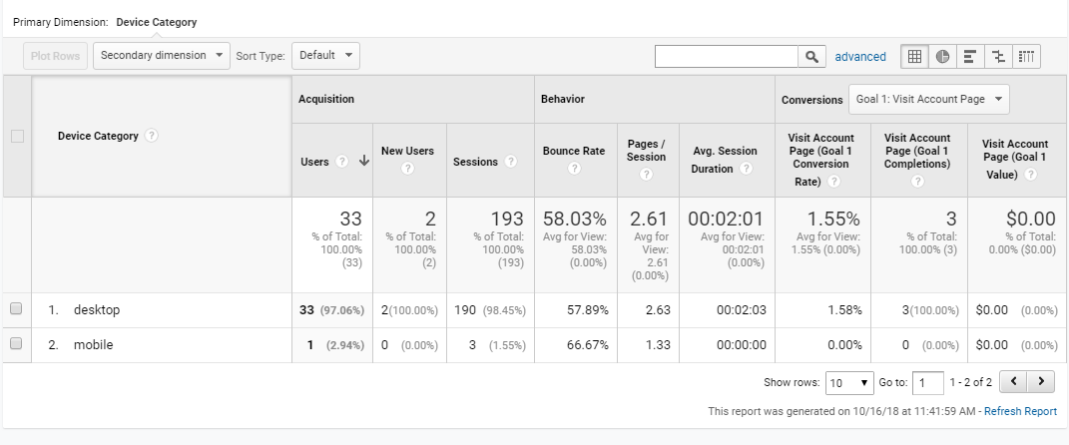

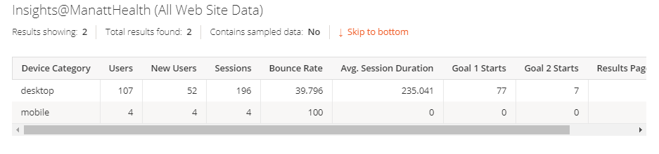

Filter: ga:deviceCategory==mobile or Desktop

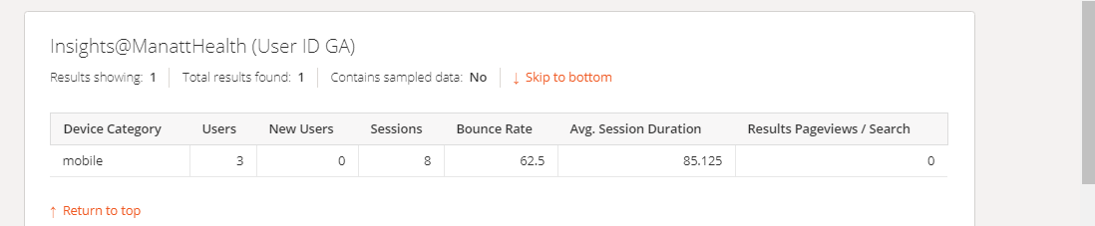

**Active Users:**

**Acquisition Overview (Filter Use)**

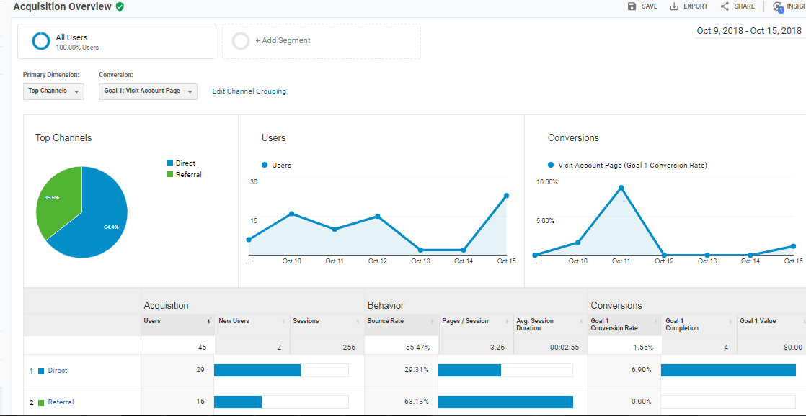

Matrics: ga: users, ga: newUsers, ga:bounceRate,ga:sessions ga:pageviews, ga:pageviewsPerSession , ga:avgSessionDuration

**Dimension**: ga:medium

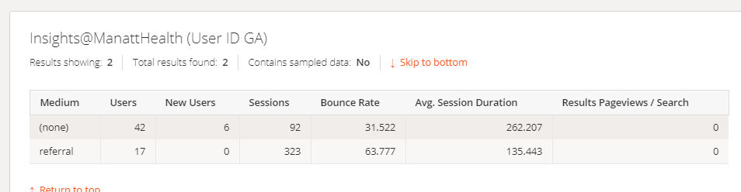

Filter : ga:medium==referral or direct

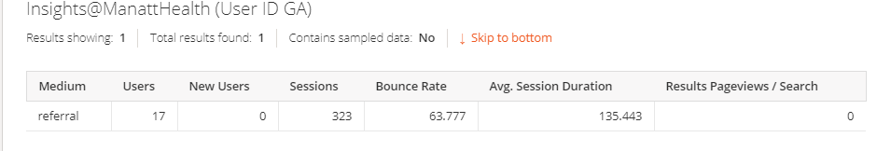

<https://ga-dev-tools.appspot.com/query-explorer/?start-date=2018-10-01&end-date=2018-10-15&metrics=ga%3Ausers%2Cga%3AnewUsers%2Cga%3Asessions%2Cga%3AbounceRate%2Cga%3AavgSessionDuration%2Cga%3AavgSearchResultViews&dimensions=ga%3Amedium&filters=ga%3Amedium%3D%3Dreferral>

<https://www.googleapis.com/analytics/v3/data/ga?ids=ga%3A166047872&start-date=2018-10-01&end-date=2018-10-15&metrics=ga%3Ausers%2Cga%3AnewUsers%2Cga%3Asessions%2Cga%3AbounceRate%2Cga%3AavgSessionDuration%2Cga%3AavgSearchResultViews&dimensions=ga%3Amedium&filters=ga%3Amedium%3D%3Dreferral>

**All Traffic-Channel**

Primary dimension: ga:channelGrouping

Matrics: ga:users, ga:newUsers, ga:bounceRate,ga:sessions ga:pageviews, ga:pageviewsPerSession 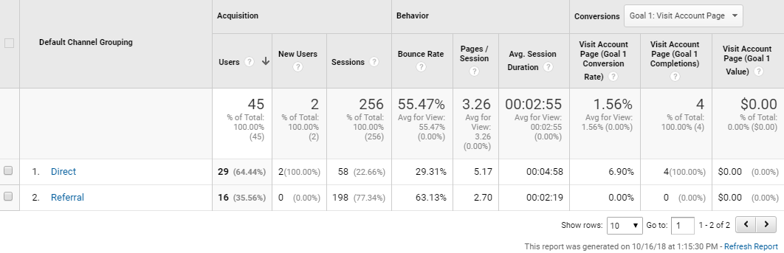

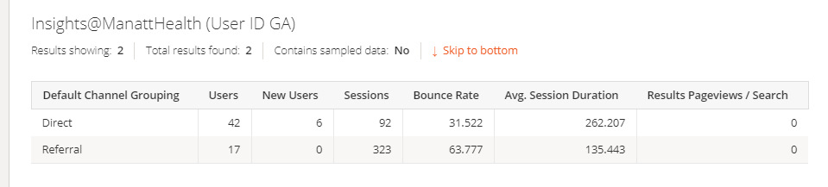

Filter=ga:channelGrouping==Direct

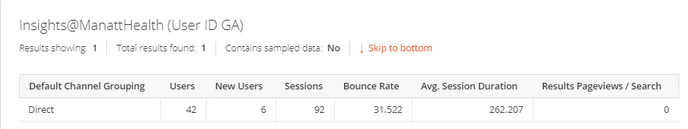

<https://ga-dev-tools.appspot.com/query-explorer/?start-date=2018-10-08&end-date=2018-10-15&metrics=ga%3Ausers%2Cga%3AnewUsers%2Cga%3Asessions%2Cga%3AbounceRate%2Cga%3AavgSessionDuration%2Cga%3ApageviewsPerSession&dimensions=ga%3AchannelGrouping&filters=ga%3AchannelGrouping%3D%3DDirect>

<https://www.googleapis.com/analytics/v3/data/ga?ids=ga%3A166047872&start-date=2018-10-08&end-date=2018-10-15&metrics=ga%3Ausers%2Cga%3AnewUsers%2Cga%3Asessions%2Cga%3AbounceRate%2Cga%3AavgSessionDuration%2Cga%3ApageviewsPerSession&dimensions=ga%3AchannelGrouping&filters=ga%3AchannelGrouping%3D%3DDirect>

**Channels: Dimension: Source / Medium,Source,Medium**

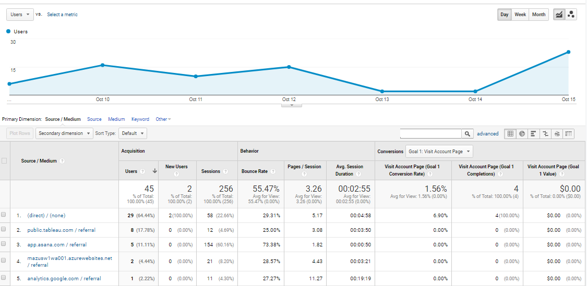

Matrics: ga:users, ga:newUsers, ga:bounceRate,ga:sessions ga:pageviews, ga:pageviewsPerSession

Dimension: ga:sourceMedium

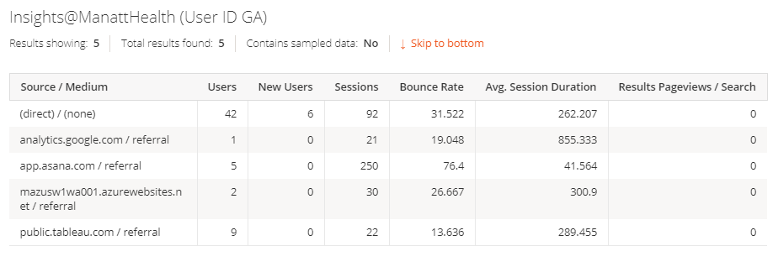

Filter:ga:medium==referral

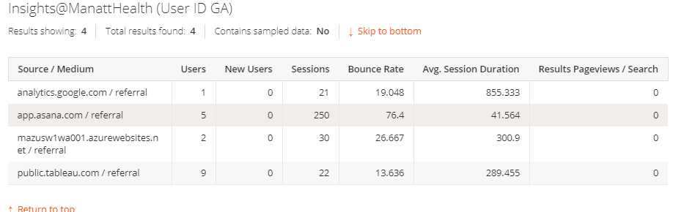

**Premium-Insights (Content Group) <<<Content Grouping for key Topic>>>>**

**Primary Dimension**: ga:landingContentGroup1

**Matrics Queries**: ga: pageviews, ga:contentGroupUniqueView1,ga:avg.timeOn Page,ga:ExitRate

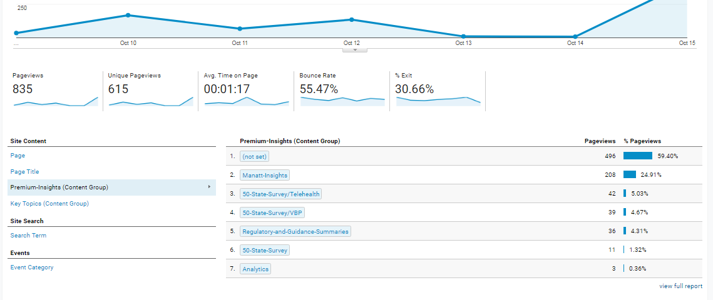

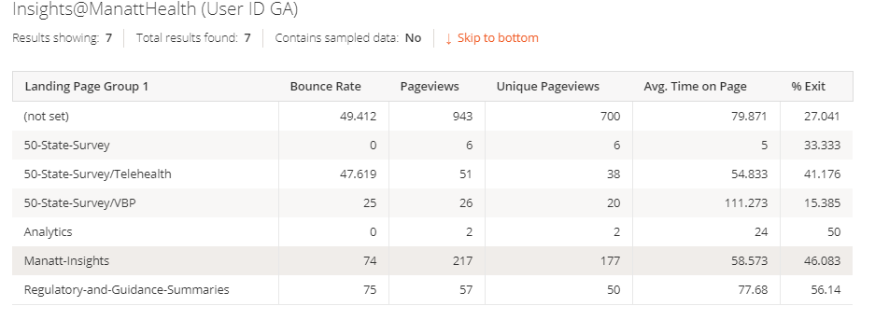

Filter: ga:landingContentGroup1==Analytics

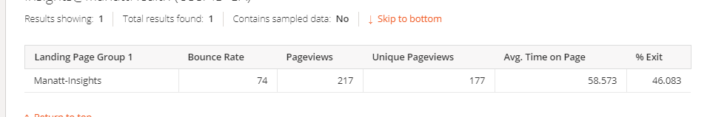

<https://ga-dev-tools.appspot.com/query-explorer/?ids=ga%3A166047872&start-date=2018-09-21&end-date=2018-10-10&metrics=ga%3AbounceRate%2Cga%3Apageviews%2Cga%3AcontentGroupUniqueViews1%2Cga%3AavgTimeOnPage%2Cga%3AexitRate&dimensions=ga%3AcontentGroup1>

<https://ga-dev-tools.appspot.com/query-explorer/?start-date=2018-10-01&end-date=2018-10-15&metrics=ga%3AbounceRate%2Cga%3Apageviews%2Cga%3AuniquePageviews%2Cga%3AavgTimeOnPage%2Cga%3AexitRate&dimensions=ga%3AlandingContentGroup1&filters=ga%3AlandingContentGroup1%3D%3DManatt-Insights>

<https://www.googleapis.com/analytics/v3/data/ga?ids=ga%3A166047872&start-date=2018-09-21&end-date=2018-10-10&metrics=ga%3AbounceRate%2Cga%3Apageviews%2Cga%3AcontentGroupUniqueViews1%2Cga%3AavgTimeOnPage%2Cga%3AexitRate&dimensions=ga%3AcontentGroup1>

**Key Topic (Content Group) <<<Content Grouping for Landing Page>>>>**

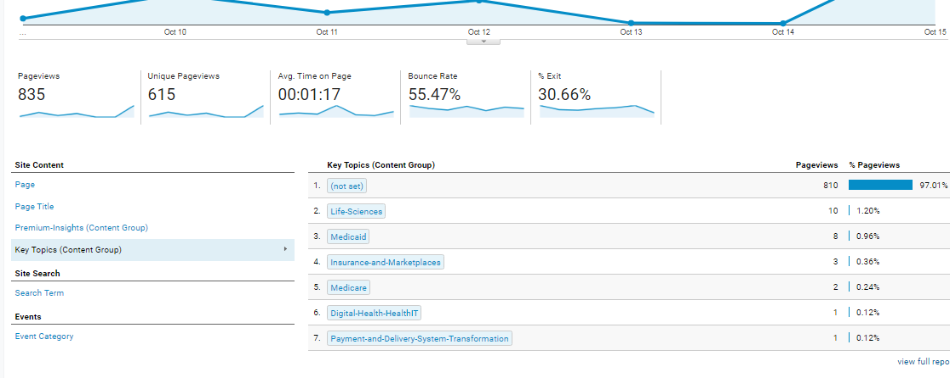

Primary Dimension: ga:contentGroup 1

Matrics Queries: ga:pageviews, ga:contentGroupUniqueViews1, ga:avgTimeOnPage, ga: exitRate

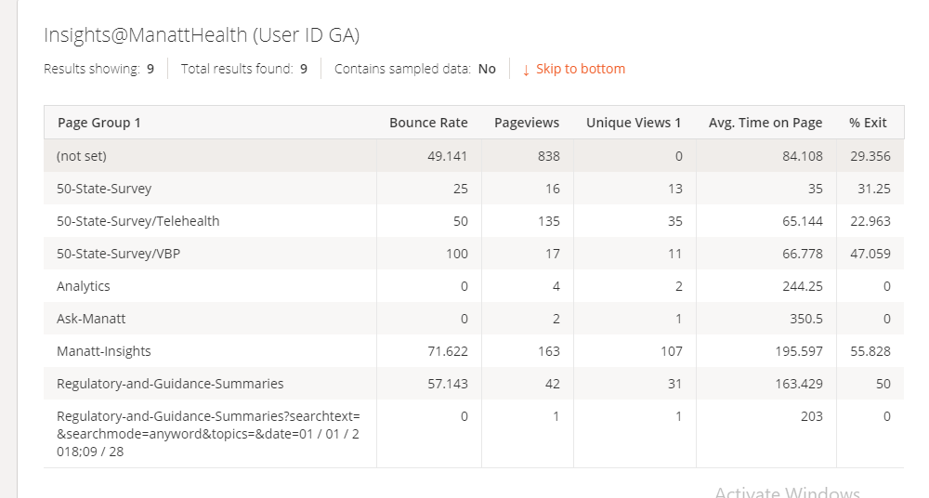

**Filter : ga:contentGroup1==50-State-Survey**

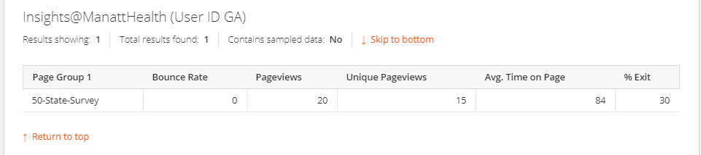

<https://ga-dev-tools.appspot.com/query-explorer/?ids=ga%3A166047872&start-date=2018-09-21&end-date=2018-10-10&metrics=ga%3AbounceRate%2Cga%3Apageviews%2Cga%3AcontentGroupUniqueViews1%2Cga%3AavgTimeOnPage%2Cga%3AexitRate&dimensions=ga%3AlandingContentGroup1>

<https://www.googleapis.com/analytics/v3/data/ga?ids=ga%3A166047872&start-date=2018-09-21&end-date=2018-10-10&metrics=ga%3AbounceRate%2Cga%3Apageviews%2Cga%3AcontentGroupUniqueViews1%2Cga%3AavgTimeOnPage%2Cga%3AexitRate&dimensions=ga%3AlandingContentGroup1>

Filter : ga:landingPagePath==/340b

**Goal Overview**

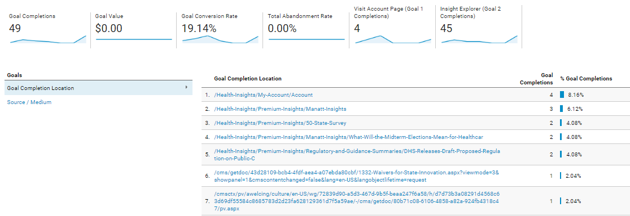

Dimension: ga:goalCompletionLocation

Metrics: ga:goalCompletionsAll, ga:goalvalueAll, ga:goalConversionRateAll, ga:goal1Completions, ga:goal2Completions

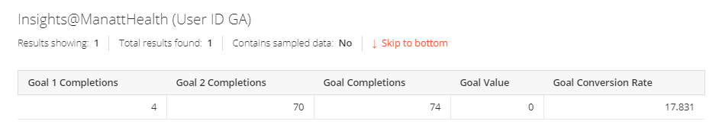

<https://ga-dev-tools.appspot.com/query-explorer/?start-date=2018-10-01&end-date=2018-10-15&metrics=ga%3Agoal1Completions%2Cga%3Agoal2Completions%2Cga%3AgoalCompletionsAll%2Cga%3AgoalValueAll%2Cga%3AgoalConversionRateAll>

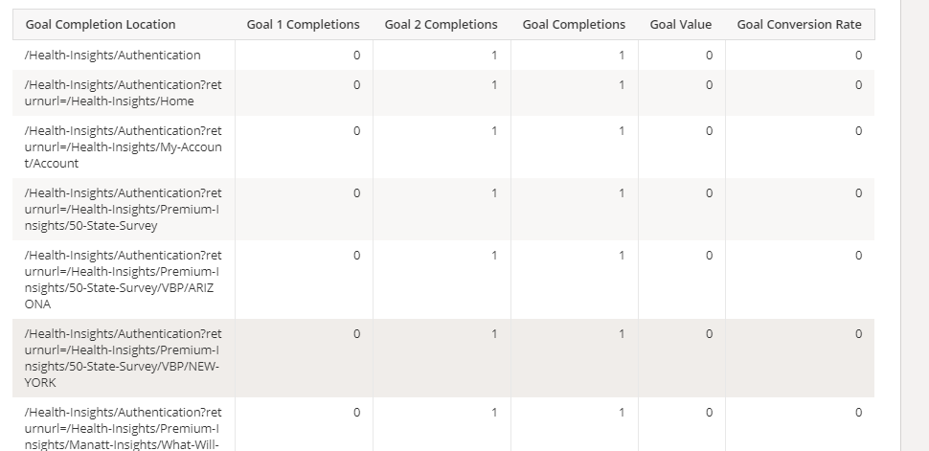

<https://ga-dev-tools.appspot.com/query-explorer/?start-date=2018-10-08&end-date=2018-10-10&metrics=ga%3AgoalStartsAll%2Cga%3Agoal2Completions%2Cga%3AgoalCompletionsAll%2Cga%3AgoalValueAll%2Cga%3AgoalConversionRateAll&dimensions=ga%3AgoalCompletionLocation>

<https://www.googleapis.com/analytics/v3/data/ga?ids=ga%3A166047872&start-date=2018-10-08&end-date=2018-10-10&metrics=ga%3AgoalStartsAll%2Cga%3Agoal2Completions%2Cga%3AgoalCompletionsAll%2Cga%3AgoalValueAll%2Cga%3AgoalConversionRateAll&dimensions=ga%3AgoalCompletionLocation>

**Goals: Source/Medium**

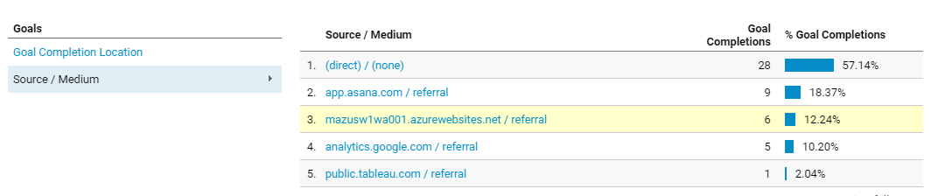

**Dimension:** ga:sourceMedium

Metrics: ga:goalCompletionsAll, ga:goalvalueAll, ga:goalConversionRateAll, ga:goal1Completions, ga:goal2Completions

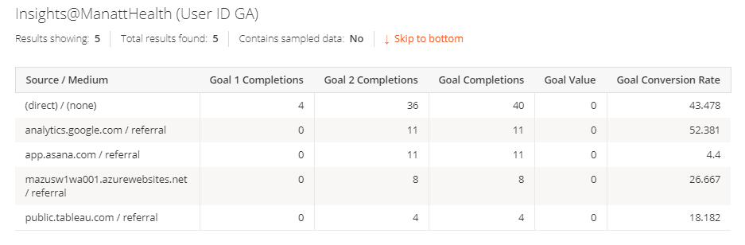

<https://ga-dev-tools.appspot.com/query-explorer/?start-date=2018-10-08&end-date=2018-10-10&metrics=ga%3Agoal1Completions%2Cga%3Agoal2Completions%2Cga%3AgoalCompletionsAll%2Cga%3AgoalValueAll%2Cga%3Agoal1ConversionRate&dimensions=ga%3AsourceMedium>

<https://www.googleapis.com/analytics/v3/data/ga?ids=ga%3A166047872&start-date=2018-10-08&end-date=2018-10-10&metrics=ga%3Agoal1Completions%2Cga%3Agoal2Completions%2Cga%3AgoalCompletionsAll%2Cga%3AgoalValueAll%2Cga%3Agoal1ConversionRate&dimensions=ga%3AsourceMedium>

**Goal URLs**

<https://ga-dev-tools.appspot.com/query-explorer/?start-date=2018-10-08&end-date=2018-10-10&metrics=ga%3AgoalCompletionsAll%2Cga%3AgoalValueAll&dimensions=ga%3AgoalCompletionLocation>

<https://www.googleapis.com/analytics/v3/data/ga?ids=ga%3A166047872&start-date=2018-10-08&end-date=2018-10-10&metrics=ga%3AgoalCompletionsAll%2Cga%3AgoalValueAll&dimensions=ga%3AgoalCompletionLocation>

**Explorer – visit 5 different landing pages**

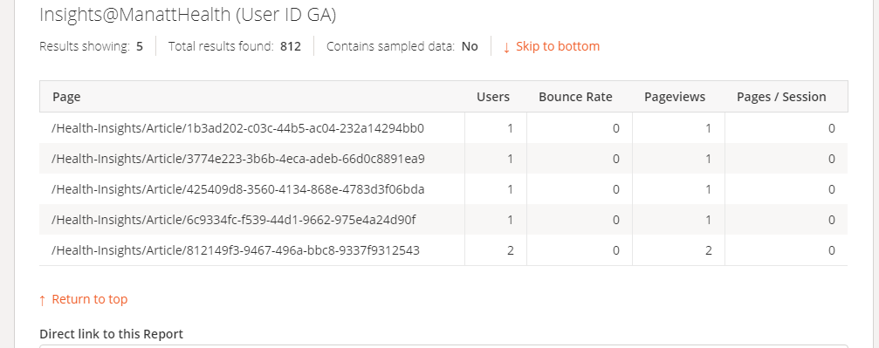

<https://ga-dev-tools.appspot.com/query-explorer/?start-date=2018-09-02&end-date=2018-10-17&metrics=ga%3Ausers%2Cga%3AbounceRate%2Cga%3Apageviews%2Cga%3ApageviewsPerSession&dimensions=ga%3ApagePath&max-results=5>

<https://www.googleapis.com/analytics/v3/data/ga?ids=ga%3A166047872&start-date=2018-09-02&end-date=2018-10-17&metrics=ga%3Ausers%2Cga%3AbounceRate%2Cga%3Apageviews%2Cga%3ApageviewsPerSession&dimensions=ga%3ApagePath&max-results=5>

**Scholar – Visit 3 content pages for 10+ minutes**

Matrics: ga;pageviews

dimensions: ga: sourceMedium, ga:pagePath

filter=ga:pageviews==10

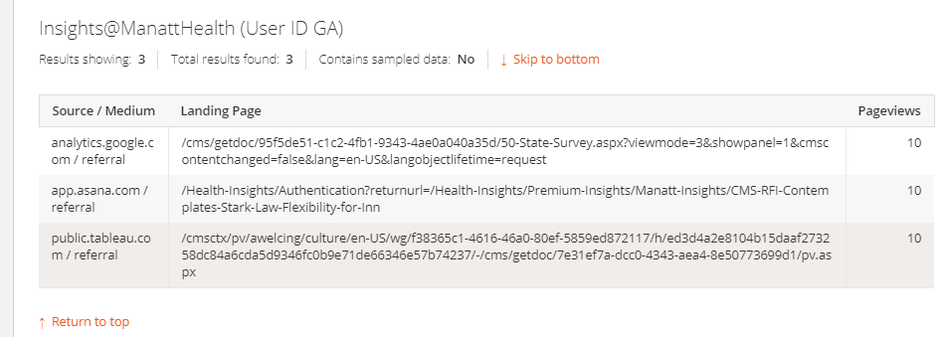

<https://ga-dev-tools.appspot.com/query-explorer/?start-date=2018-09-02&end-date=2018-10-17&metrics=ga%3Ausers%2Cga%3AbounceRate%2Cga%3Apageviews%2Cga%3ApageviewsPerSession&dimensions=ga%3ApagePath%2Cga%3AlandingPagePath&filters=ga%3Apageviews%3D%3D10&max-results=3>

<https://www.googleapis.com/analytics/v3/data/ga?ids=ga%3A166047872&start-date=2018-09-02&end-date=2018-10-17&metrics=ga%3Ausers%2Cga%3AbounceRate%2Cga%3Apageviews%2Cga%3ApageviewsPerSession&dimensions=ga%3ApagePath%2Cga%3AlandingPagePath&filters=ga%3Apageviews%3D%3D10&max-results=3>

**Time on page**

Matrics: ga:users, ga:timeOnPage

Dimension: ga:source/medium, ga:landingPagePath

Filter ga:timeOnPage==10

<https://ga-dev-tools.appspot.com/query-explorer/?start-date=2018-10-01&end-date=2018-10-15&metrics=ga%3Ausers%2Cga%3AtimeOnPage&dimensions=ga%3AsourceMedium%2Cga%3AlandingPagePath&filters=ga%3AtimeOnPage%3C10>

<https://www.googleapis.com/analytics/v3/data/ga?ids=ga%3A164098161&start-date=2018-10-01&end-date=2018-10-15&metrics=ga%3Ausers%2Cga%3AtimeOnPage&dimensions=ga%3AsourceMedium%2Cga%3AlandingPagePath&filters=ga%3AtimeOnPage%3C10>

**<<<<<<<<<<<<Events>>>>>>>>>>>>>>>>>>>**

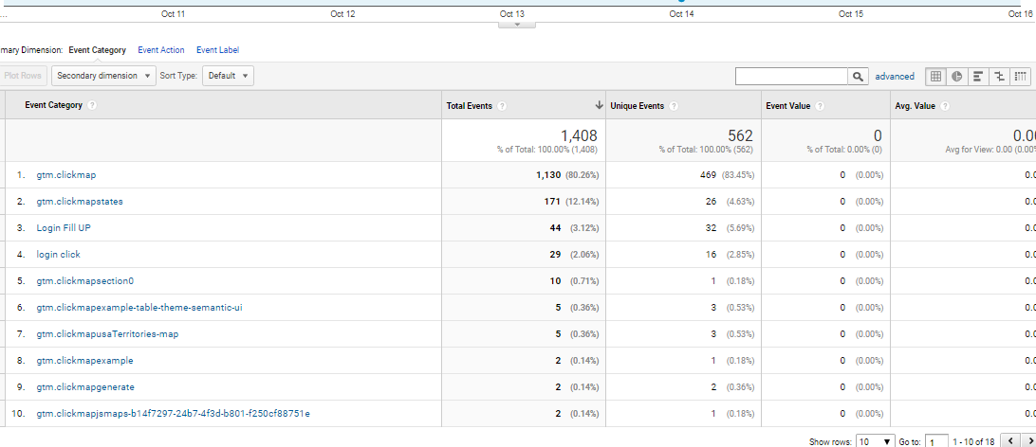

Dimension: ga: eventCategory

Matrics: ga: totalEvents, ga:eventValue, ga:avgValue

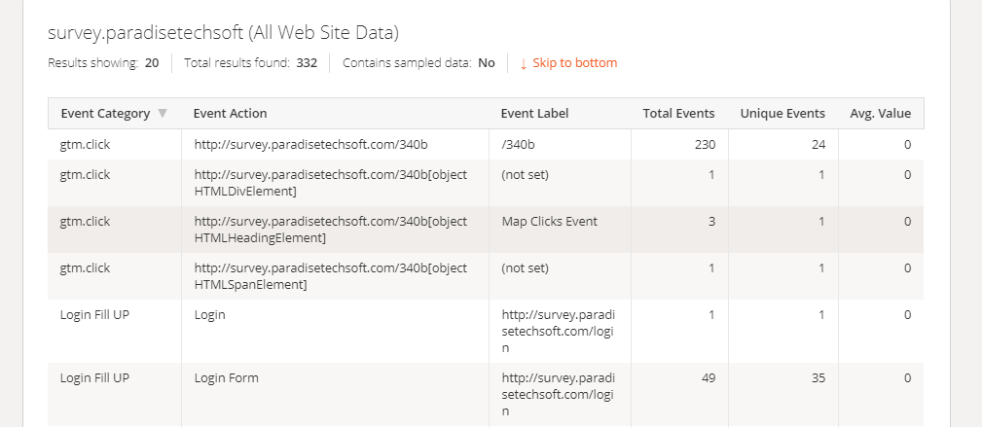

<https://ga-dev-tools.appspot.com/query-explorer/?start-date=2018-09-25&end-date=2018-10-16&metrics=ga%3AtotalEvents%2Cga%3AuniqueEvents%2Cga%3AavgEventValue&dimensions=ga%3AeventCategory%2Cga%3AeventAction%2Cga%3AeventLabel&samplingLevel=FASTER&start-index=2&max-results=100>

<https://www.googleapis.com/analytics/v3/data/ga?ids=ga%3A182580713&start-date=2018-09-25&end-date=2018-10-16&metrics=ga%3AtotalEvents%2Cga%3AuniqueEvents%2Cga%3AavgEventValue&dimensions=ga%3AeventCategory%2Cga%3AeventAction%2Cga%3AeventLabel&samplingLevel=FASTER&start-index=2&max-results=100>

**Access from a mobile/tablet device**

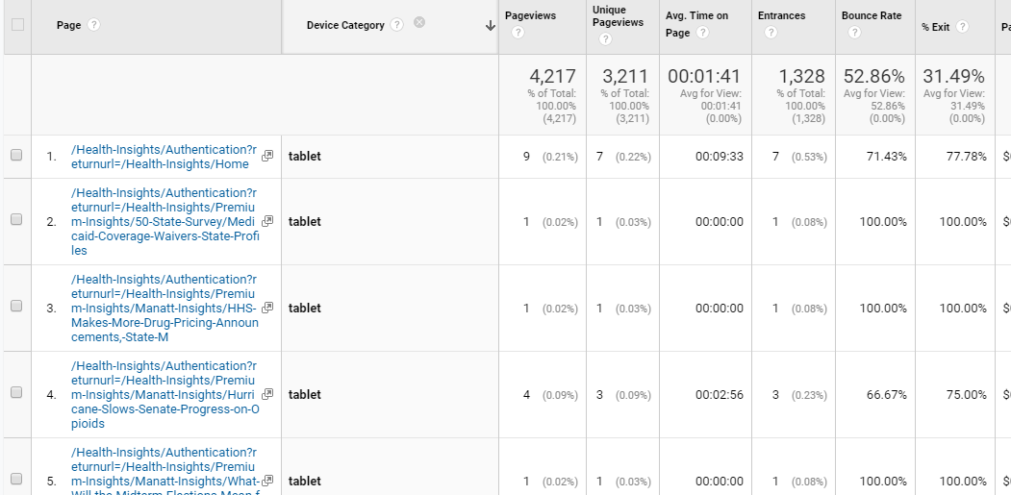

Dimension: ga:pagePath, ga:deviceCategory

Matric:ga:users, ga:bounceRate, ga:pageviews, ga:pageviewsPerSession

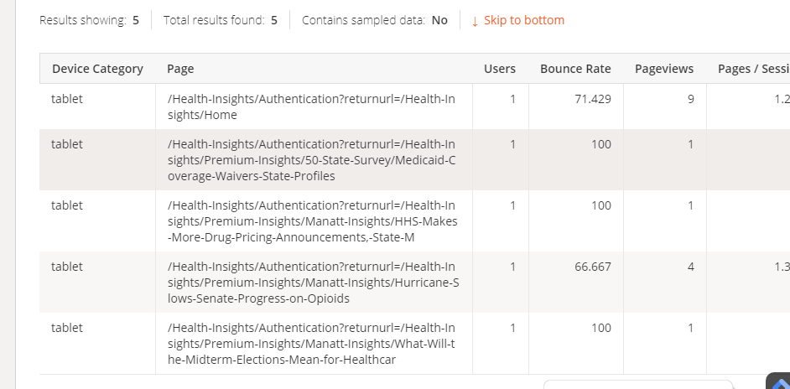

<https://ga-dev-tools.appspot.com/query-explorer/?start-date=2018-09-02&end-date=2018-10-17&metrics=ga%3Ausers%2Cga%3AbounceRate%2Cga%3Apageviews%2Cga%3ApageviewsPerSession&dimensions=ga%3AdeviceCategory%2Cga%3ApagePath&filters=ga%3AdeviceCategory%3D%3Dtablet&max-results=5>

<https://www.googleapis.com/analytics/v3/data/ga?ids=ga%3A166047872&start-date=2018-09-02&end-date=2018-10-17&metrics=ga%3Ausers%2Cga%3AbounceRate%2Cga%3Apageviews%2Cga%3ApageviewsPerSession&dimensions=ga%3AdeviceCategory%2Cga%3ApagePath&filters=ga%3AdeviceCategory%3D%3Dtablet&max-results=5>

**Acquisition Overview- Top Channel**

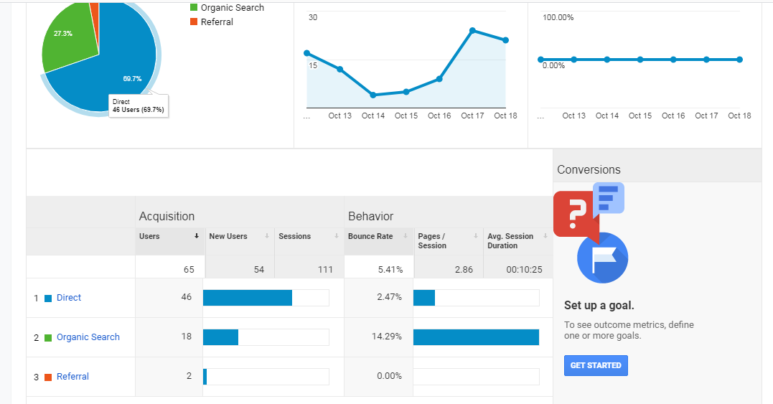

Primary dimension: Top Channel

Secondary Dimension: ga:users, ga:newUsers,ga:sessions, ga:bounceRate,ga:pageViewPerSession,ga:avgSessionDuration

Matric: ga:session

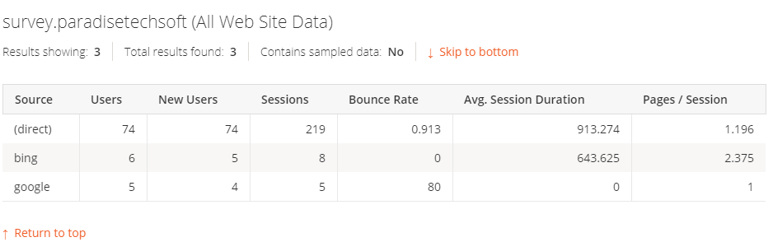

**ExplorerNavigation Summary**

**Dimension: ga:pagePath, ga:fullReffer**

**Matrics:** ga:pageViews, ga:uniquePageViews,ga:avgTimeOnPage , ga:entrances, ga:bounceRate

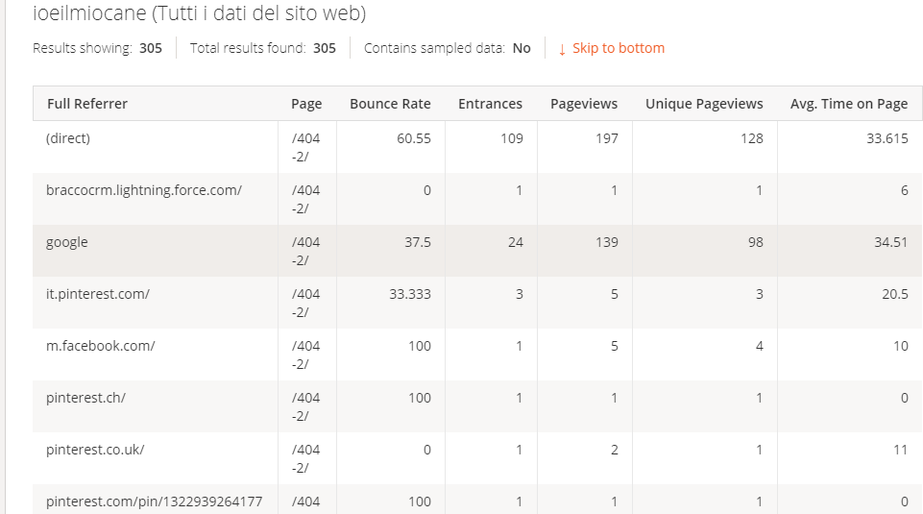

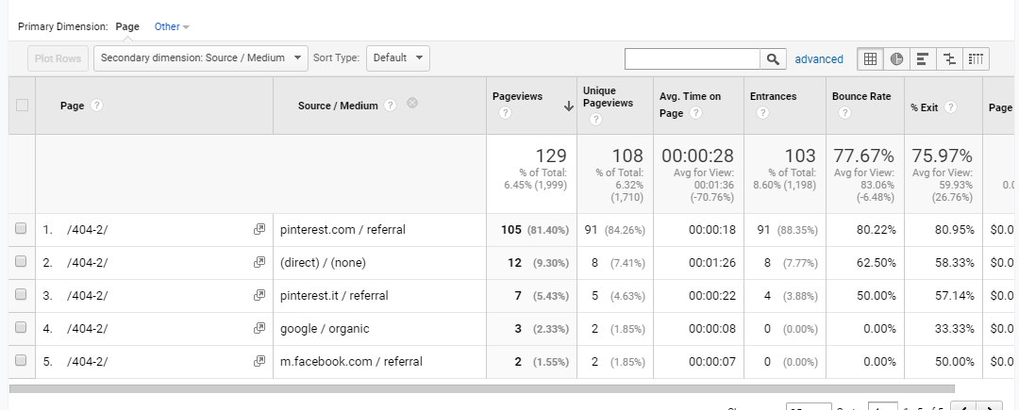

**Real time Overview**

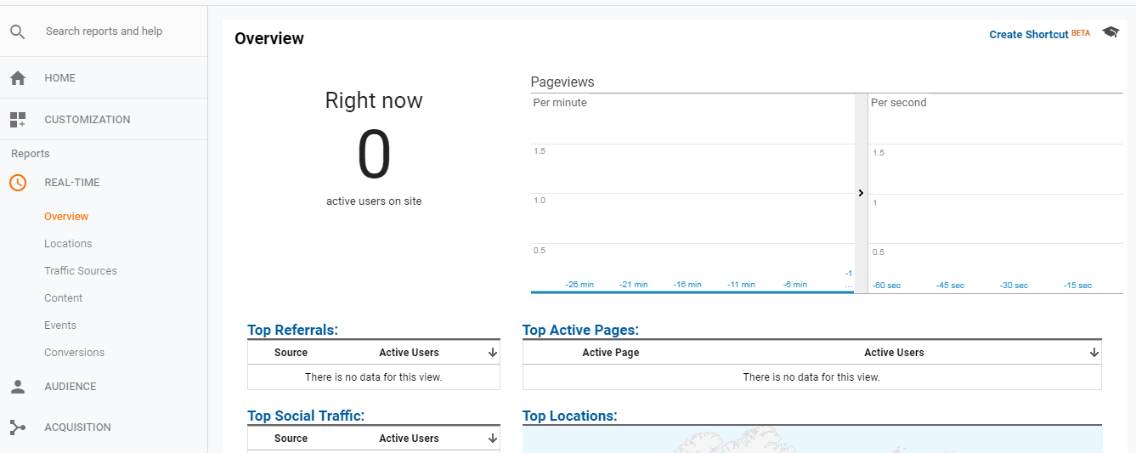

* **metrics:** ga:users
* **dimensions:** ga:eventCategory,ga:eventAction,ga:eventLabel
* **filters:** ga:eventCategory==ui_category_A;ga:eventAction==ui_action;ga:eventLabel== Click_button_A
* **start_date:** today
* **end_date:** today

**Real Time Reporting API Private Beta**

<https://docs.google.com/forms/d/e/1FAIpQLSc9OpoDGB3tBD7oy1OG9fyum8KBIxs-2ihPCsHp13WTnM-SSQ/viewform>

# What pages do your users visit most?

# 

# Matric: ga:pageView, ga: uniquePageView, ga:avgPageOnTime

# Dimension: ga:pagePath

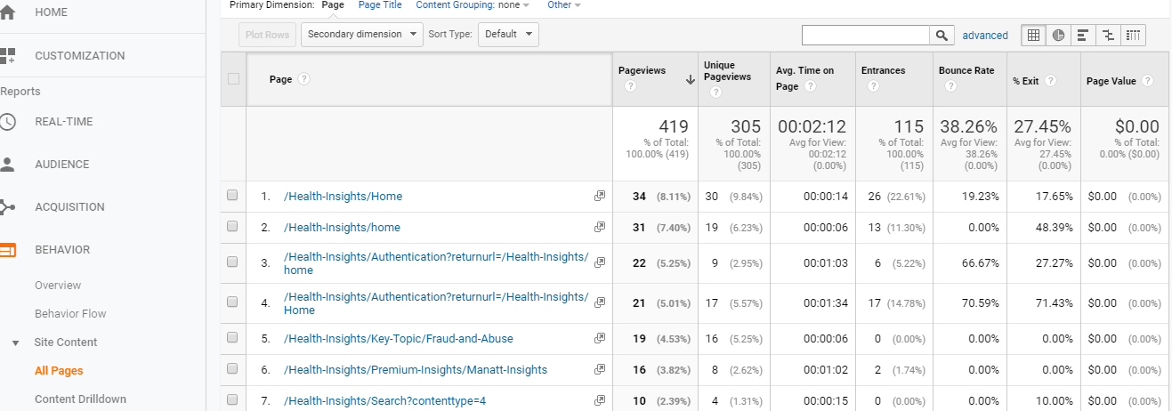

<https://ga-dev-tools.appspot.com/query-explorer/?start-date=2018-10-01&end-date=2018-10-23&metrics=ga%3Ausers%2Cga%3AnewUsers%2Cga%3Apageviews%2Cga%3AuniquePageviews%2Cga%3AavgTimeOnPage&dimensions=ga%3ApagePath&max-results=10>

<https://www.googleapis.com/analytics/v3/data/ga?ids=ga%3A166047872&start-date=2018-10-01&end-date=2018-10-23&metrics=ga%3Ausers%2Cga%3AnewUsers%2Cga%3Apageviews%2Cga%3AuniquePageviews%2Cga%3AavgTimeOnPage&dimensions=ga%3ApagePath&max-results=10>

**AUDIENCE**: **Location**

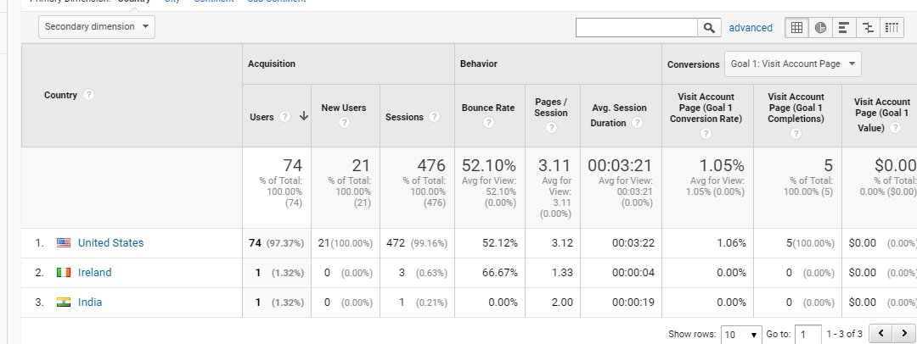

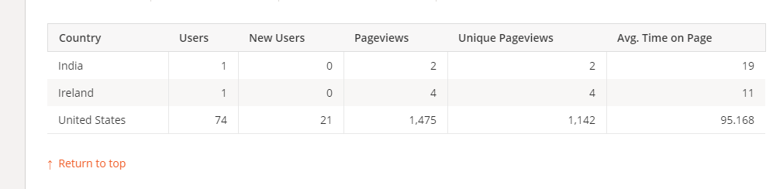

Metrics:

Dimension:

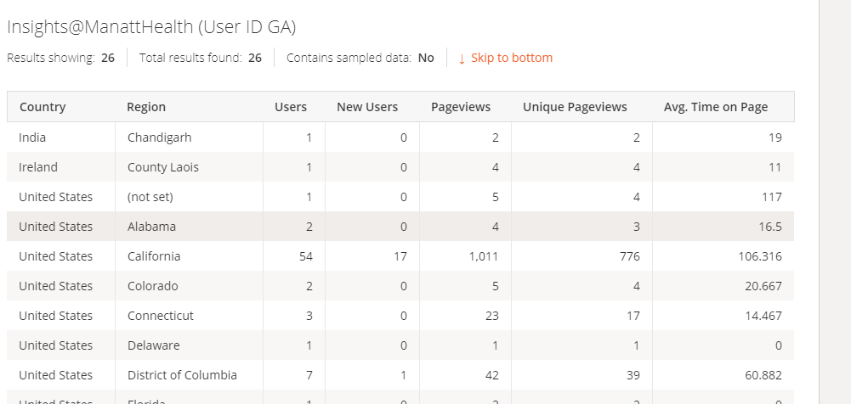

**Show user id:**

Views only start tracking from the day - the minute - they were created, they can't back-fill. So of course a view you just created doesn't show anything.

